Are differences for the good or for the bad? I sure would like to know. For differences are all around us, in every place we go.

There is a difference between a boy and a girl. There is a difference between a guy and a gal. Furthermore, there is a difference between a man and his pal.

New babies are born with differences every day. These differences could determine their daily pathway.

I am a woman whose different than most. I married a man whose differences I will note. Our differences are fine; they keep us in line.

They make us work together, in difficulty and pleasure.

Many times, we argue. This keeps us apart. We discovered forgiveness; and this difference, opened our hearts.

They say, “Love is everlasting”. We did a lot of fasting.

They say, “Love is true”. Perhaps, it’s hidden in you.

We left behind past sorrow; as we walk into our tomorrow.

We love only in today; and we push all foolish doubts away.

**Differences (Spiritual)**

I speak of my faith, my hopes, and my dreams

You speak of your traditions, and live opposite to what they mean.

**Differences (Activity)**

I like to stay home, watch movies, and talk

You like to travel, watch sports, and walk.

**Differences (Audio)**

I listen to music that raises me, toward heavenly treasures

You listen to music that stimulates you, toward earthly pleasures.

**Differences (Mental)**

I rely on a pill that I hope will keep me healthy

You rely on a lottery that you hope will make you wealthy.

**Differences (Argumentum)**

If I say, “Let’s go right”, then you will say, “Let’s go left”

If I say, “Let’s be fast”, then you will say, “Let’s be last”.

**Differences (Physical)**

I am small. You are tall.

**Differences (Appetite)**

I prefer vegetables and fruits; they are light and good for my nutrition

You prefer starches and meats; they are heavy and hard for your digestion.

**Differences (Environmental)**

I surround myself with folks, who guide me, as I grow

You surround yourself with folks, who criticize what you know.

**Differences (Philosophical)**

I read and write, to keep myself enlightened and educated

You go out and play, to keep yourself entertained and intoxicated.

**Differences (Financial)**

I give a portion of my earnings, to help those in need

You spend most of your earnings, to buy everything you see.

**Differences (Summary)**

We are all different and this is all right; for without God’s wisdom, our differences, would lead us to fight. He forgives all our differences and gives us our freedom.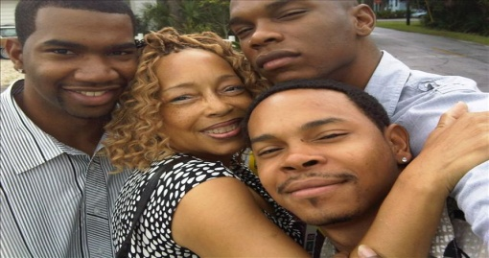 His primary goal is to lead us into His kingdom.

Written By: Theresa Quarterman Brack Dedicated to My Sons: Graylan, Terron, Esrom, All My Love, Mother